Nuclearisation: A Deterrent to Maintain Peace in South Asia
Professor (Dr) Sukhwant S. Bindra

Byline:
It is generally assumed that the decision of one nation to develop and strengthen nuclear capability generally encourages, particularly its neighbors, to go for nuclearisation.

Herman Kahn and Joseph S. Nye Jr. are two distinguished theorists who have contributed significantly to deterrence theory. It is generally believed that deterrence theory is a revised version of realist postulates. According to the realist point of view, threats of war are as old as war itself and are part and parcel of traditional international conflict and crisis management. After the advent of nuclear weapons, however, deterrence has assumed a greater importance and emerged as a separate component of relations among nations.
To deter is to discourage through fear. Deterrence is an important tool and practice of interstate management, how threats of resorting to force of any type by any party to convince the other to refrain from using coercive methods. Throughout history, countries built and strengthened their military capability, formed alliances, and issued threats to deter other countries from attacking. Although the whole scenario has changed drastically in the nuclear age. Nuclear deterrence is based upon the assumption that “If you attack me, I may not be able to prevent your attack, but I can retaliate so powerfully that you will not want to attack in the first place.”
Earlier, the decisions regarding strengthening military capability were the privilege of the top-level experts in most of the developing and developed countries. The public was not at all in the picture, but with the passage of time and the sweeping changes that took place in world politics, it has injected several new dimensions, particularly about public awareness of military and strategic matters. In the contemporary world, it is not possible to take broad military decisions without any public debate.
The political elites, to put a seal of legitimacy on their policies and programmes, in fact, encouraged the public to initiate debates and discussions on important matters of all types that are directly or indirectly concerned with national security or military setup. In Pakistan, three major “overlapping elite groups” political, economic, and social are in operations: The political group include, (a) leaders of various political parties, (b) top level military and air force offices, since the third wing of armed forces i.e. navy, has not been able to attract ambitions of the land- owning class therefore, it has not exercised a great deal of power and influence relative to the armed forces (c) the central elite civil services in particular the civil services of Pakistan and the Pakistan Foreign services, (d) other members of the land owing family, belonging to Punjab and Sindh who have adopted other professions outside civil service and military. But in the economic elite group, major importance is attached to industrialists. The decision-making process in Pakistan has usually been highly centralised and personal. No doubt, the continuity has been maintained through civilian and military bureaucracy in respect of domestic and foreign policy, military and strategic matters.
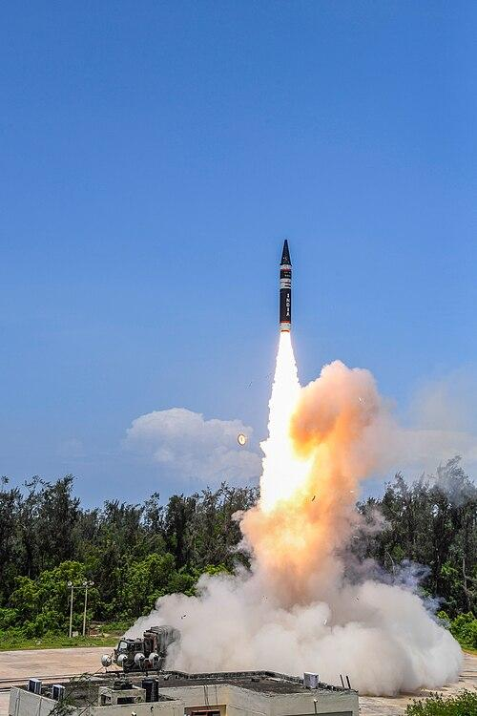Agni-P First Launch
Source : wikipedia.org
However, in the Indian context, the picture is entirely different, following the British pattern, and that’s still working, of course, changes were incorporated according to the changing and amended circumstances. The decision-making process is transparent, and the legislature, executive, and judiciary work together, no doubt sometimes with differences of opinion and political compulsions or otherwise. The army remains in barracks and works under the civilian, political, and bureaucratic elites. The army is not involved in the day-to-day running of administration except when civil administration needs any help to tackle natural disasters and calamities. The Parliamentary system implemented in India since 1947 has faced many challenges and opportunities, with a quasi-federal support system. India and Pakistan both emerged on the world map as independent nations at the same time, but have survived on the world pedestal with different priorities, foreign policy objectives, and national interests.
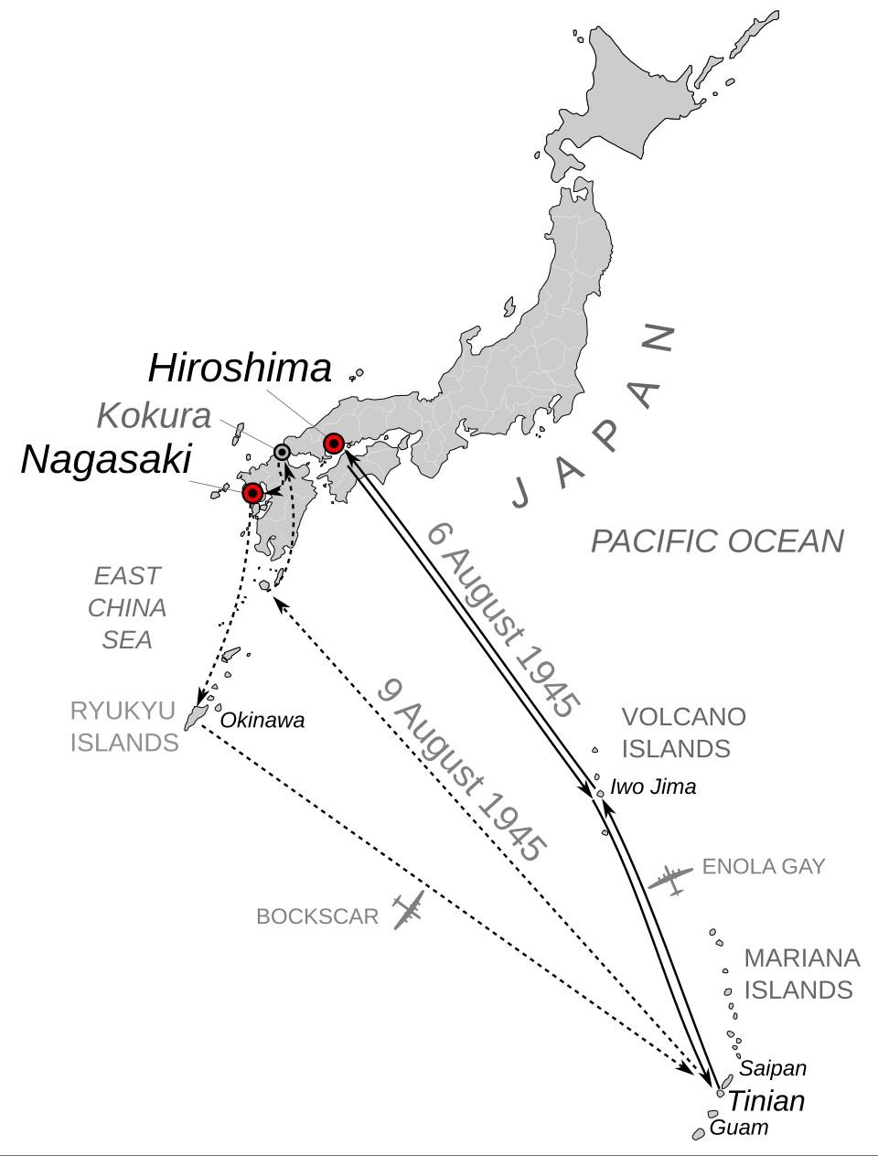

Atomic bomb 1945 mission map
Image Source : wikimedia.com

In general, further strengthening of military capability is sometimes necessary to protect the territorial integrity of a country and to acquire sophisticated military technology or update military hardware. This impression varies from one country to another and more particularly depends on its geo-strategic location, some specific foreign policy and strategic objectives, covert and overt. Ideological moorings and bent of mind of the political elites in power or aspiring to be in power also disturb the peace and security of a region in particular and the international environment in general.
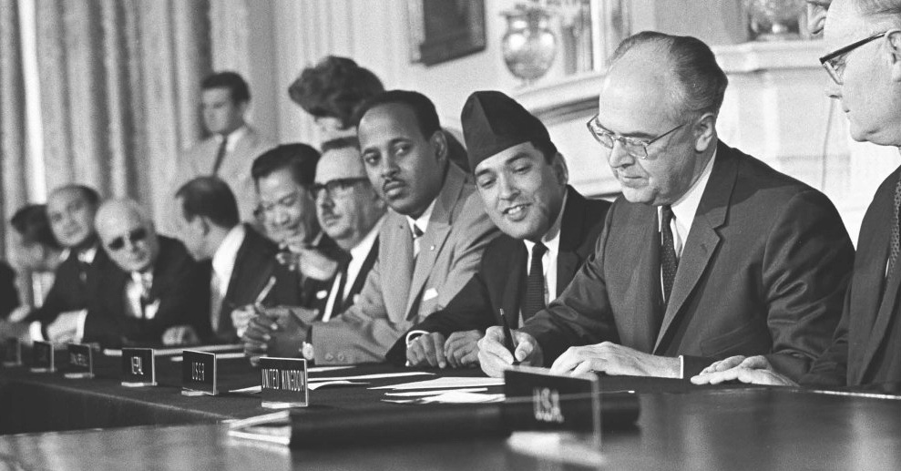
1968 Non-Proliferation Treaty (NPT)
Source : icanw.org
The shattering impression of the public mind of those climactic moments of twentieth-century history came from the revelation of the two inextricable dimensions of nuclear weapons, the first relating to their incredible power and the second to the unconscionable destruction and unimaginable suffering that they embody and symbolize. Nuclear weapons emanate wonder and horror. They have continued to do so ever since.
The most ardent advocates of nuclear weapons have constantly sought to invest these weapons with a virtually religious authority and importance and to give them an accepted and respectable place in the most popular culture of the contemporary world. What better way is there to legitimise their existence than to do one or both of these things? If nuclear weapons can come to acquire the same “profound value as the sacred symbols that supposedly condense the meaning and purposes of a religion and of the surrounding then can be seen as arcane and complex as the higher reaches of religious philosophy can be for the ordinary believer or the uninitiated, then we have surely succeeded in making the politics and ideology of the possession of nuclear weapons virtually incontestable”.
The other approach also seeks to make the presence of nuclear weapons and the discourse that justifies it contestable, but it does so not by seeking to place it on a pedestal to be reversed from afar or below. Rather, it so immerses in the web of everybody's life and values of a mass society that their presence is “normalised” and considered unexceptional and unobjectionable. These two approaches, the religious and the cultural–popular, may appear to work at cross purposes, but they don’t. Indeed, the greatest success is delivered when the two can be fused, when the religious – sacred is both reversed and seen as an unproblematic and normal part of everyday life.
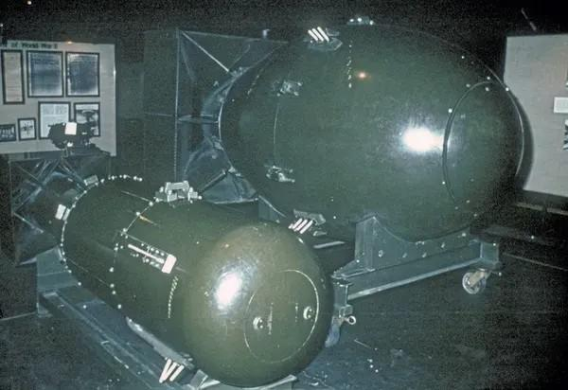
Little boy and fat man
Source : mediastorehouse.com
The great dilemma for the advocates of nuclear weapons and the good hope for those who unreservedly oppose them is that despite all efforts to either sanctify or popularise these arguments and the attention ideology of support, these efforts have never been able to gain anywhere near as much ground as its purveyors have wished. This has certainly not been for want of trying. Ever since such weapons were invented, pro-nuclearists have been trying to make them into desirable icons, to build glorious myths and weave attractive images around them, to generalise and domesticate their meanings. Yet there is this relative failure.
It is a well-known fact that the United States dropping of nuclear bombs on the two most populous cities of Japan, Hiroshima and Nagasaki, in October 1945, changed the whole concept of relations among nations, as it was considered to be the main cause of the rift between the US and the Soviet Union after the end of the Second World War. The Soviet leadership considered the secretly manufacturing of nuclear devices and detonating without taking in to confidence the Allied Powers, a betrayal on the US part which created a wedge between the two countries and beginning of mutual suspicion also, culminated later tension and distrust which led to the dividing the world in to two power blocs and setting of the cold war which almost for more than three decades created uncertainty and posed a serious challenge to the world peace and security.
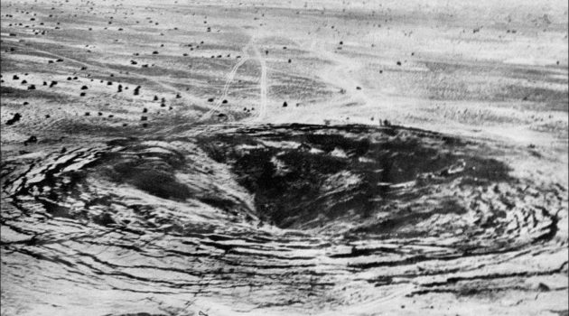Operation smiling Buddha Crater
Source : atomicphotographers.com

In September 1949, the Soviet Union successfully conducted nuclear tests and emerged as the second country joining the nuclear club, followed by Britain on 3rd October 1952, France on 13th February 1960, and China on 16th October 1964. In the South Asian region, India detonated its first nuclear device in May 1974, which, of course, prompted Pakistan to rush for nuclear weapons, and the nuclear policy of Pakistan went through a new direction.
It is generally assumed that the decision of one nation to develop and strengthen nuclear capability generally encourages, particularly its neighbors, to go for nuclearisation. China's joining of the nuclear club in 1964 encouraged India to make appropriate changes in its nuclear policy, and a bomb lobby emerged in India in the mid-sixties, which started putting pressure on the Indian government to go nuclear. The same situation emerged after India detonated nuclear devices when the Pakistani government decided to produce a nuclear device by hook or crook.
Peace and threats to use force have persistently been a part of international relations, and developments in military technology have often had an important impact on structures and processes of political systems. Thermonuclear weapons and long-range ballistic missile systems are not merely quantitatively different from those that preceded them. They also possess qualitative attributes that have led and will continue to have a significant impact on the international system, its member units, and the nature of relations between them. This is not to say that the conventional weapons are obsolete, indeed most nations' military forces are still limited to such weapons, and even nuclear powers have found it expedient to maintain conventional forces to deal with limited provocations.
It is not only the destructive capacity of nuclear weapons that has had an impact on the international system. The development of long-range ballistic missiles has provided the means for the delivery across continents at speeds that have reduced warning time almost to the vanishing point. Space and time, which once protected against surprise attack, have all but lost their defensive edge in the nuclear missile age. Since the Second World War, the policies of nations aimed at nuclear weapons have clearly dominated the international system, but the acquisition and deployment of military instruments is by no means limited to the major powers. Thus, although nuclear weapons are of undeniable importance, several important points should be kept in mind: (1) Virtually all the nations maintain armed forces; (2) the intensity of violence in military actions may vary across a wide scale, but force is rarely used in an unlimited manner; (3) sources of international instability are by no means confined to the actions and conflicts between nuclear powers, and (4) many observations about force as an instrument of policy are equally void for nuclear and for conventional weapons.
Military strength has traditionally been one of the attributes distinguishing the so-called great powers from the small powers. Since the Second World War, destruction has tended to give way to that between the nuclear powers and those not so armed. The high cost of developing and procuring nuclear capabilities initially prohibited all but a few industrial powers from developing them. At present, nuclear technology has tended to create two classes of international citizenship. In the long run, however, nuclear capabilities may tend to dilute the importance of traditional bases of power – population, territory, industrial capacity, and the like – and therefore, reduce rather than expand the difference between large and small nations.
To be sure, a nation with a large population, vast territory, and widely dispersed industrial capacity may be in a better position to survive a nuclear attack – and is thus capable of employing threats more effectively than a nation with limited population and territory. In the pre-nuclear era, it was unlikely that a minor power could inflict an unacceptable level of damage on one of its large neighbours, much less threaten its existence; it was not inconceivable, however, that in the not-too-distant future, a small nation armed with nuclear weapons might be in a position to inflict such damage. This is precisely the reasoning that underlies the French “force de dissuasion”. The ability to tear off an arm is assumed to be sufficient to deter even a much more powerful adversary.
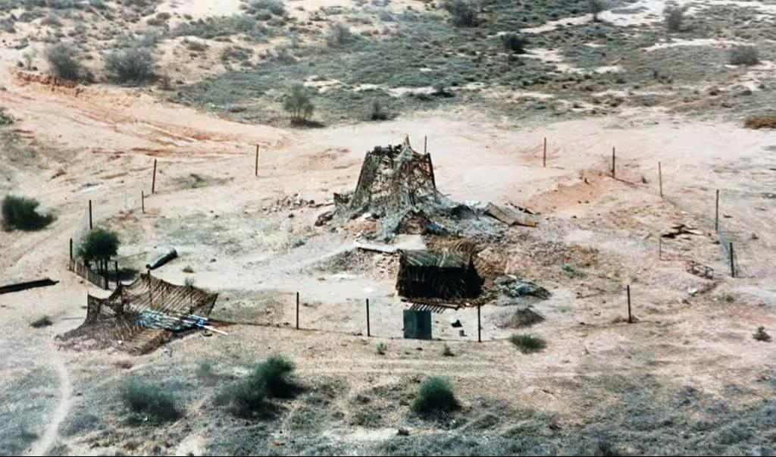
Operation Shakti (Pokhran-II)
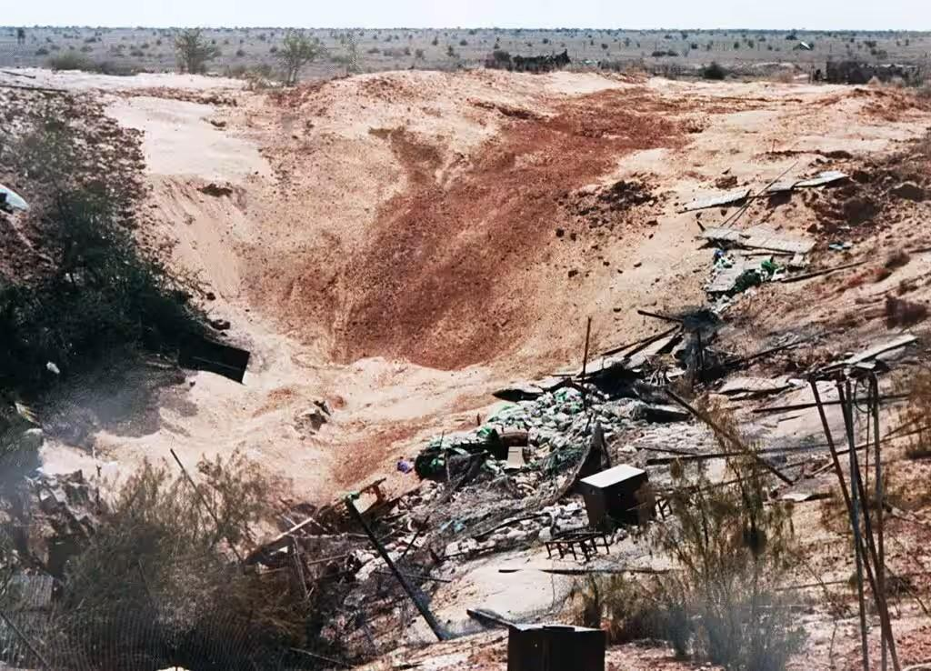
Operation Shakti (Pokhran-II) (After detonation), May 11, 1998
Source : wionews.com
However, for most nations, nuclear power is currently only indirectly relevant to the conduct of their foreign policies. Although possessed of weak and crude military capabilities in comparison to those of the nuclear nations, these countries also enjoy the advantage of being unlikely direct targets of any nuclear exchange. It is thus one of the many paradoxes of the nuclear age that the threat of destruction hangs most heavily even on those states with the greater military power; in some respects, security is inversely rather than directly related to military capabilities.
The nuclear weapons, whose destructive power was so convincingly demonstrated at Hiroshima and Nagasaki in 1945, became a symbol of power and prestige among the nations of the world, and their possession gave a special status to the possessor in the international power hierarchy. Since 1945, various measures to freeze, limit, or abolish certain categories of weapons, to prevent certain military activities, to regulate the development of forces, to prescribe the transfer of certain military important items, to construct or prohibit the use of certain arguments to build up international confidence through greater openness in the military field have come to be included in the rubric of arms control. It was consistently upheld that 20 to 25 nations might acquire nuclear capability around 1985, and the scenario would be that of more or less a “Nuclear Armed Crowd.”

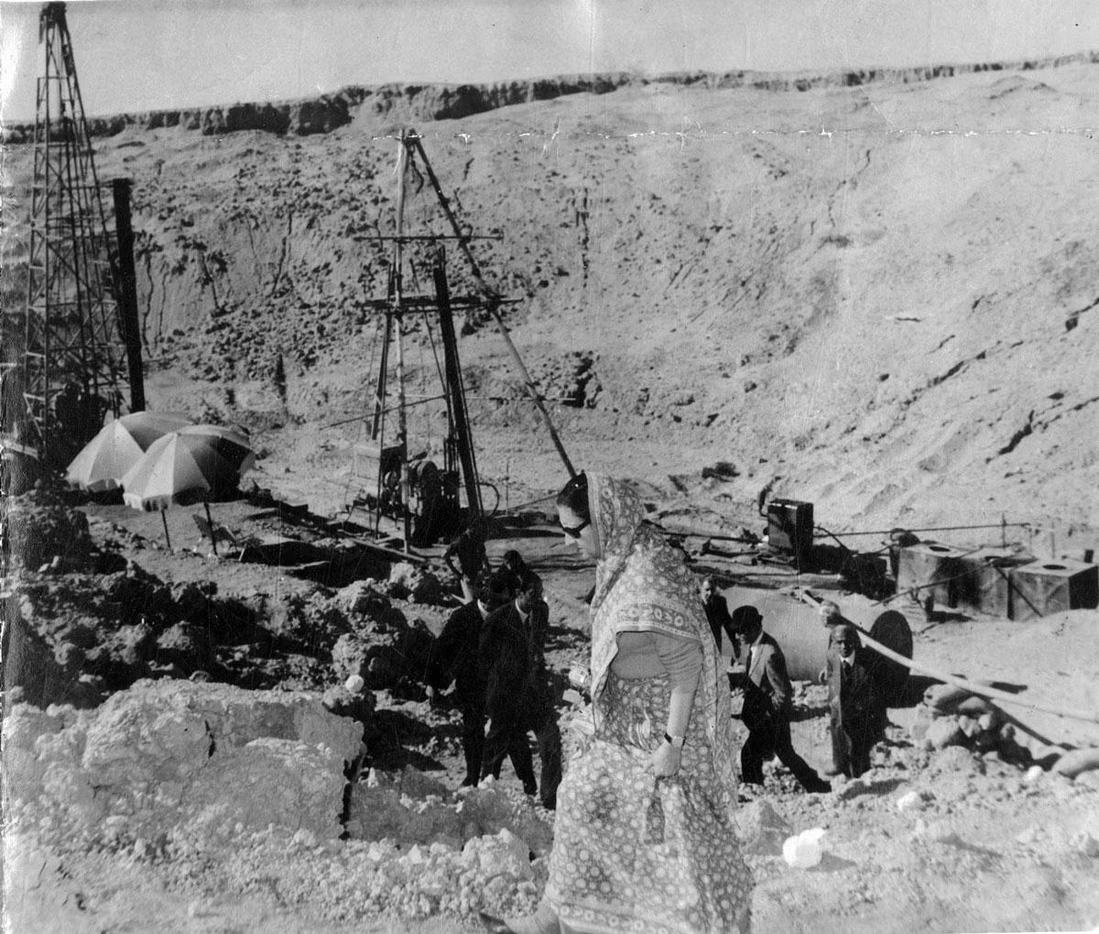Prime Minister Indira Gandhi visits Pokhran, 1974
Image Source : indianexpress.com
This did not become a reality because the spread of nuclear capability was contained efficiently to an extent by others and the nuclear-weapon states, like the US. It tried to arrest the spread of nuclear weapons to other countries and regions where they did not exist. This proliferation within a political lexicon came to be understood as the concern of some (states, intellectuals, and media) with others' possession of nuclear weapons because of those others’ alleged willingness to play by the rules of the game.
The evaluation of international order over the past seventy years has been radically different in a variety of respects from the way international events had unfolded with two hundred years of building colonial empires. The onset of the nuclear age ushered in an era where nuclear weapons were to become instruments of furthering the hegemonic ambitions of the states that possessed them as instruments of mass destruction. The process of horizontal nuclear proliferation itself can be viewed as a historical process where adversary threat perceptions lead to a kind of chain reaction or a struggle against nuclear hegemony, which results in more nations going nuclear. Thus, the US nuclear weapons programme capitalised on the former USSR nuclear weapons programme. The Chinese nuclear deterrent was directed at both the US and the USSR. Chinese capability spurred it.
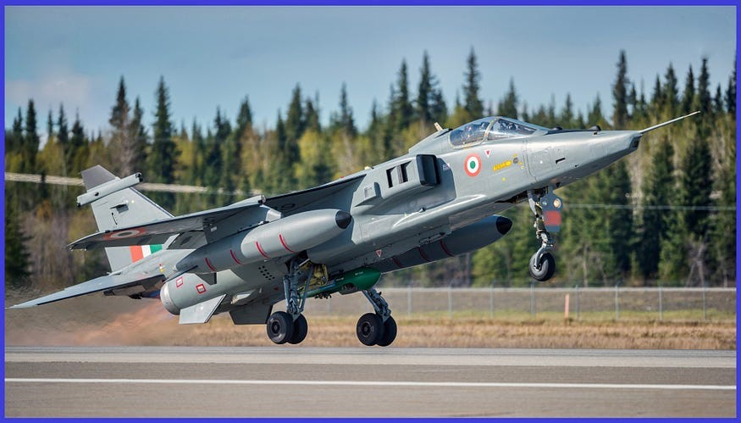SEPECAT Jaguar, supersonic jet attack aircraft
Several factors have encouraged this sense of insecurity. First, the Hindu-Muslim divide, together with deeply ingrained memories and experiences of exploitation and suffering, has been a more powerful barrier to accommodation and reconciliation between the two major states. Between India and Pakistan, these historical realities have generated attitudes that are not conducive to innovative thinking in the region. Second, the dictates of “negative substances”, which constantly emphasised the dissimilarities between cultures to preserve the justification for the partition of the subcontinent in 1947, have largely determined the policies of those in power, particularly in Pakistan and Bangladesh. While this too is receding, the new reference points that can guide the present generations are still evolving, making the present leadership in the region quite difficult. Third, in the subcontinent, different sets of arrangements have evolved. The dissimilarities in the structures and aspirations of the elites in each country, the parliamentary, military, and monarchical rulings that are prevailing in the region, are responsible for the development of a self-serving system of values and attitudes ipso facto, preliterate to seemingly irreconcilable conceptions of security. Fourth, keeping into consideration the differences in size and potential between the states of South Asia, India, which has common borders with each country, although none of the neighbours border on each other, inevitably emerges as the predominant factor in the security parameters of the region, the domestic as well as other.
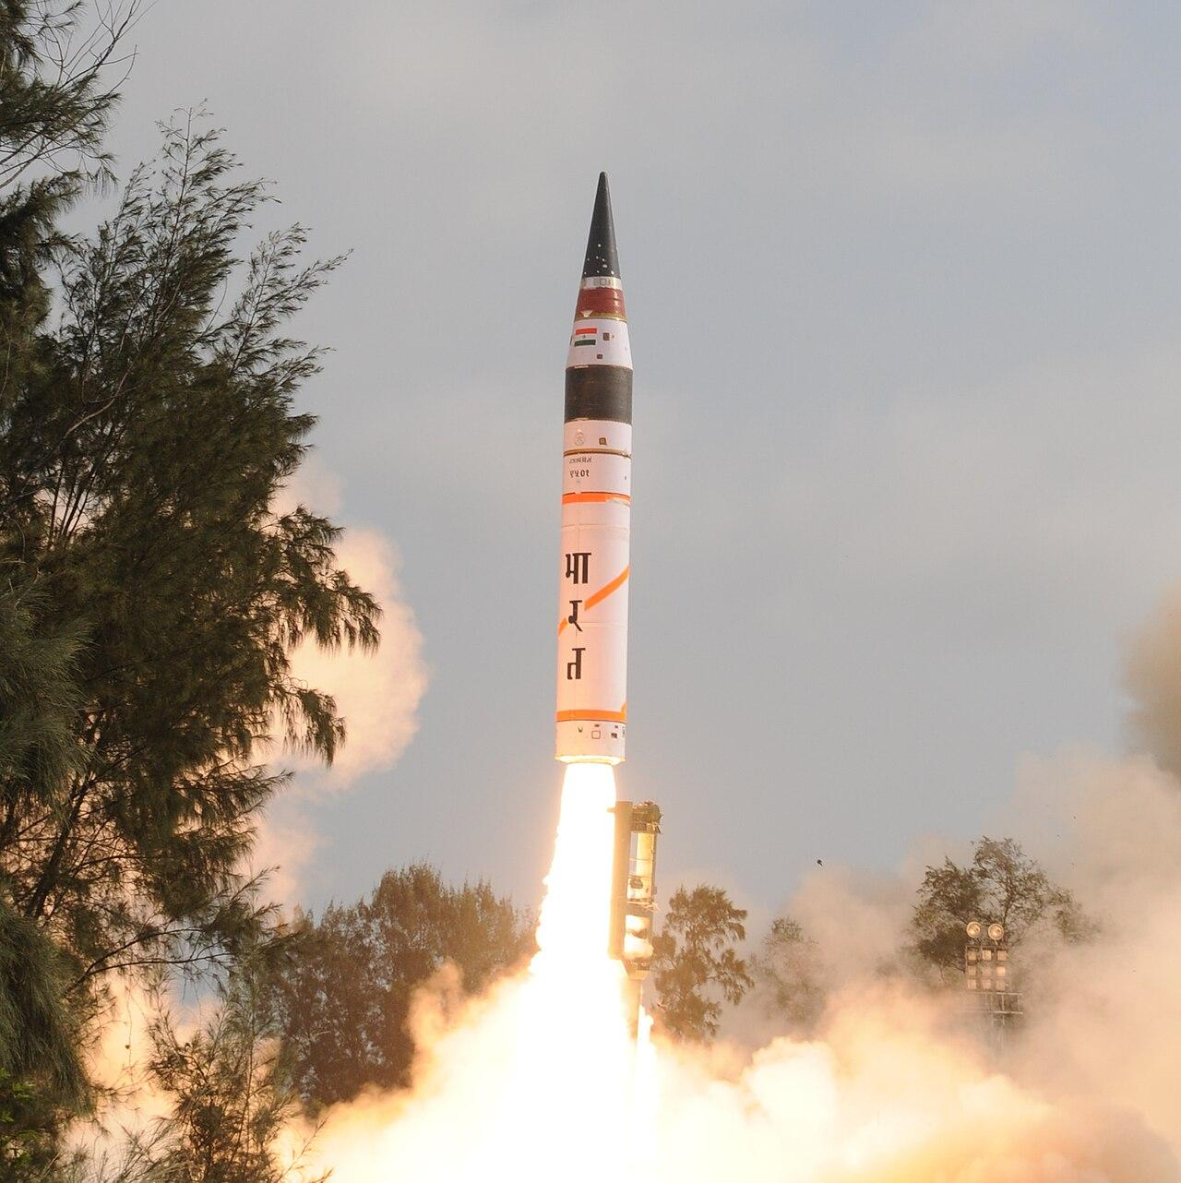
Agni - V ; Image Source : medium.com
And lastly, post 1947 developments such as six major wars involving China, Pakistan, India and Bangladesh, the dismemberment of Pakistan, creation of Bangladesh, merger of Sikkim into India, the explosion of nuclear devices by India and Pakistan, demographic aggression (from Bangladesh to India), the trade war between India and China, India and Nepal, cross border terrorism and its direct and indirect impact on South Asia to name only a few have created a security environment that raises more doubts and concerns than hope and optimism. There has emerged in the subcontinent a pattern of thinking in which there are only two adversaries, India and its neighbors, with each accusing the other of being the primary cause of regional unrest and security.
The nuclearisation of India and Pakistan helps create peace between the two unfriendly neighbours and in the South Asian region in general. The Kargil Crisis of 1999 created a peculiar situation when Pakistan feared the crossing of the Line of Control in the Kashmir valley by the Indian Army and invading Pakistan’s Occupied Kashmir. The then Prime Minister of Pakistan, Nawaz Sharif, reacted sharply and categorically stated that “other options are open for Pakistan”, like resorting to the use of nuclear weapons against India. The then US President Bill Clinton intervened and called Nawaz Sharif to Washington, warning him of exploring the “other options.” The warning deterred Pakistan, and the conflict ended gradually.
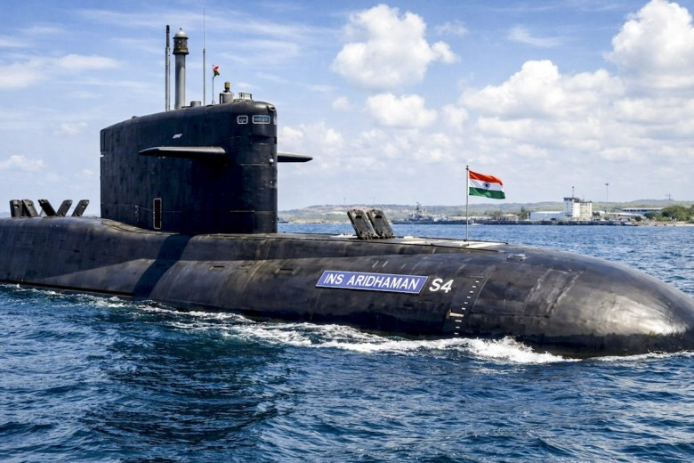
INS Aridhaman, India’s third indigenous nuclear-powered ballistic missile submarine (SSBN)
Image Source : thehindu.com
Operation Sindoor was launched by India in the first week of May 2025 against Pakistan to destroy the terrorists’ camps operating secretly on Pakistan’s territory. The operation abruptly ended as it was probably believed that Pakistan might use nuclear weapons. As claimed by the US President Donald Trump, he advised both countries to end the conflict and sit across the table to resolve their differences. In both cases, the nuclear deterrent worked successfully.

